PLEX Tool User stories

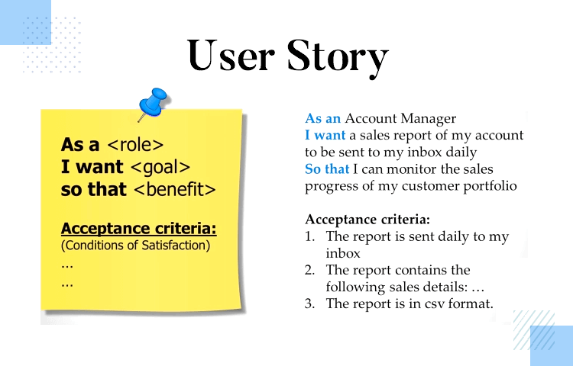

Wensley Podrono,

Donovan Khoun,

Nick Kruize,

Steijn Sweere,

Michael Vroegop,

Sam Boers

# 

# Student stories

**As a** student

**I want to** login with my FHICT account

**so that** I can use the application without needing an extra account and my information is readily available

**As a** student

**I want to** see projects that the teacher has made available for my class

**so that** all the projects my class can choose are easy to find

**As a** student

**I want to** be able to see information about a project

**so that** I can make a good decision about the project I want to do

**As a** student

**I want to** view multiple projects

**So that** Ican see the available projects

**As a** student

**I want to** view a specific project

**So that** Ican see the details of that particular project

**As a** student

**I want to** select and change my favorite projects

**So that** Ican show my teacher what project(s) I would like to work on.

**As a** student

**I want to** sort my projects in order of preference

**So that** Ican show my teacher what project(s) I would like to work on the most

**As a** student

**I want to** see the projects I have saved as a favorite

**So that** Isee what I have previously selected

**As a** student

**I want to** receive a message when I am required to favourite a project

**So that** Ican take action and make my selection

# 

# Teacher stories

## Priority stories

**As a** teacher,

**I want to** receive a list of proposed placements for students based on their preferences.

**So that,** Ican monitor the placements and whether I agree with the proposition

**As a** teacher,

**I want to** be able to import projects from DEX.

**So that,** I do not have to manually create them, and students can work on pre-existing projects.

**As a** teacher,

**I want to** log in with my FHICT account.

**So that,** I can use the application without needing an extra account and my information is readily available.

**As a** teacher,

**I want to** use the classes which are defined in Canvas

**so that** I can use an existing class.

**As a** teacher,

**I want to** be able to manually appoint students to a project.

**So that,** I can exert some control over the student placements.

**As a** teacher,

**I want to** be able to let the system take care of appointing the students to projects.

**So that,** I can save some time.

**As a** teacher,

**I want to** be able to manually create projects.

**So that, I** can add course crucial projects in case they're missing from DEX.

**As a** teacher,

**I want to** be able to search for projects with keywords.

**So that I,** can find the projects I am looking for more easily.

**As a** teacher,  
**I Want to** create a class/course manually.  
**So that, I** can place students into different classes/courses manually.

**As a** teacher,  
**I Want to** edit the details of a class/course.  
**So that, I** can update the relevant information of the class.

**As a** teacher,  
**I Want to** see a list of students which shows only their first name, last name, and student number (GDPR/AVG).  
**So that, I** can add the students to project groups.

**As a** teacher,  
**I Want to** sort students by class/course.  
**So that, I** can quickly see in which course they are enrolled.

**As** a teacher,  
**I want** to be able to add a student to a class/course.  
**So that, I** can manage the courses.

**As a** teacher,  
**I want to** remove a student from a class/course.  
**So that, I** can manage the classes/courses.

**As a** teacher,

**I want to** see an overview of all the available projects.

**So that, I** can select the projects I want to present to my students.

**As a** teacher,

**I want to** curate projects for courses and add them to a *playlist.*

**So that, I** can provide the proper projects for them and enables me to grade them better.

**As a** teacher,

**I want to** remove projects from the playlist.

**So that, I** can remove unwanted/unnecessary projects for the students.

**As a** teacher,

**I want to** be able to share my playlist with students.

**So that, they** can quickly see the projects I have selected for them.

**As a** teacher,

**I want to** be able to see which projects students have chosen.

**So that, I** can properly appoint projects to students.

**As a** teacher,

**I want to** be able to link a student to a project.

**So that they,** can then be divided into groups.

**As a** teacher,

**I want to** be able to remove a student from a project.

**So that, the groups** are modifiable.